**TRY OUTS**

**( Apply Suitable Matlab functions and do the Following operations and check with the manual calculation)**

**1.Evalutate the polynomial : Y = x3 + x2 +5x + 3**

**At ( x=5)**

**At (x=1)**

**2. Find the roots of the polynomial : (i) 5x2+2x+1 = 0**

**(ii) 7x3+5x+5 =0**

**3. Add two polynomials : x+y+z and x2+x+y+5 // Make it as vector of same length.**

**4. Subtract the two polynomials: 5x3+6x+1 and x2+1 // Difference**

**5. Find the product of 2 polynomials :**

**(i) (x2+1) and (x3+x2+1)**

**(ii) (x3+5x) and (x4+x2+1)**

**6. Perform division over the given polynomials : Divide x by y**

**x=5z2+5z+1 and y=5z+1**

**7. Determine the Polynomial with the roots 3,-5**

**8. Find the characteristic of a Polynomial A**

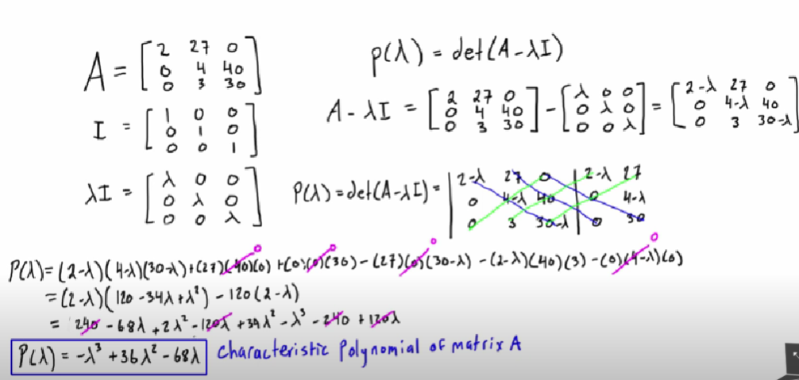

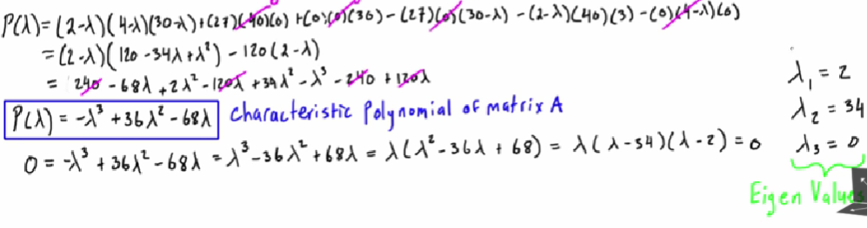

**Find the solution:**

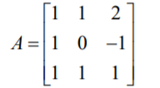

**9. Find the solution for the following : Polynomial differentiation:**

**10. Polynomial integration:**